**Assignment 1 : Project Ideation**

Name: Wildan Luqmanul Hakim

1. Understand the overview of the Community Portal from Project Mentor.

|  |  |  |
| --- | --- | --- |
| No | Questions | Answers |
| 1 | What website do you visit often? | it's like an educational website |
| 2 | What about community portal? | yes, it’s help many people |
| 3 | Do u have problem with community portal? | yes, I have little bit problem |
| 4 | What the problem? | it's hard to navigate the website when their is to much content |
| 5 | How you make better on website? | maybe using login and search some like that |

1. Persona
   1. List the different personas who will be using the Community Portal, with brief description of each of the personas.

|  |  |  |
| --- | --- | --- |
| No | Persona | Brief Description |
| 1 | Rudolf Lange | Rudolf Lange is a 25 year old digital marketer, and he wants to be a programmer. |
| 2 | Nika Volkova | Nika Volkova is a 21 year old Harvard graduate, she wants to become a software engineer and get a job |

* 1. Create a Personas profile with Demographics, Behaviours & Beliefs, Characteristics & Goals for 2 Personas defined.

|  |  |
| --- | --- |
| Persona (1): | Rudolf Lange |
| Demographics: | 25, Male, Scottish, Employed |
| Behaviors and Beliefs: | Like to play golf  Hit the ball as far away |
| Characteristics: | Optimistic, calm, artistic, introvert |
| Goals: | Become an advanced programmer |

|  |  |
| --- | --- |
| Persona (2): | Nika Volkova |
| Demographics: | 21, Female, Russian, Unemployed (Fresh Graduate) |
| Behaviors and Beliefs: | Travelling  Holidays make me fresh |
| Characteristics: | Friendly, brilliant, extroverted |
| Goals: | Want to go around the world |

1. Conduct Ideation for the Project Scenario and come up with 2 Ideas to meet the Project Scenario

Scenario Name: Login Page

|  |  |
| --- | --- |
| No | Ideas |
| 1 | User visit the website and open home page  User click login button at top right home page  User Input their username and password then click login button  If User input their username and password is correct then will direct to home page again |
| 2 | User go to the homepage  If the user hasn't saved their login on the website, a login pop-up will appear.  User Input their username and password then click login button  If the username and password are correct, the login popup will disappear. |

1. Create Scenario & Storyboard for one of the Scenarios

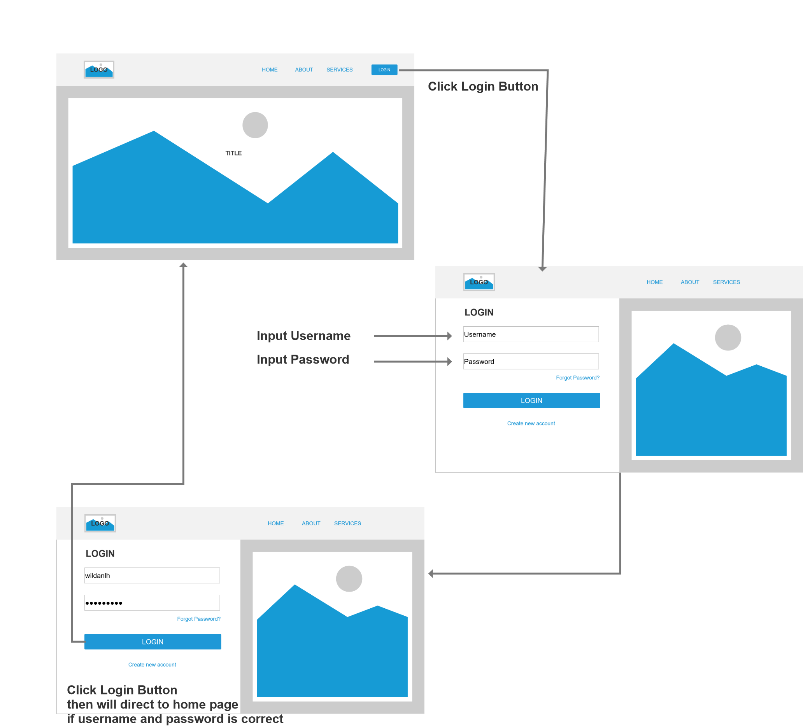

1. Use Axure to Create a Wireframe Prototype for 1 Scenario

Scenario Name: Login Scenario

|  |  |
| --- | --- |
| Wireframe pages | Specifications (Widget Table) |
|  | 1. Logo Website   Logo for icon the website   1. Menu Home   Will direct to Home Page   1. Menu About   Will direct to About Page   1. Menu Services   Will direct to Services Page   1. Button Login   Will direct to Login Page   1. Picture Title   For the welcome |
|  | 1. Logo Website   Logo for icon the website   1. Menu Home   Will direct to Home Page   1. Menu About   Will direct to About Page   1. Menu Services   Will direct to Services Page   1. Heading Login   For make sure user in the login page   1. Text Field Username   For User to input their username   1. Text Field Password   For User to input their password   1. Link Forgot Password?   For help user if user forgot the username or password   1. Button Login   If the username and password correct will direct to homepage   1. Link Create Account   For make new account for user   1. Picture   To make an attractive display |

|  |
| --- |
| ZIP File |

1. Plan the Implementation for the Project Scenario

|  |  |
| --- | --- |
| Priorities | Scenarios |
| Top | 1. Make registration for user 2. Forgot password to help user if user forgot username or email 3. Make login with username and email |
| Medium | 1. Login with Google account 2. Make checkbox to auto Login if user checked the remember me check box 3. Search Bar 4. Chat system with another user |
| Nice to have | 1. User can rate the website 2. Create an attractive website |